Digital fundraiser
REPORTING TO: Head of Digital
WORKING HOURS: Monday – Friday 9.00am – 18.00pm
LOCATION: Holborn Studios, Eagle Wharf N1 and Remote
AREA OF RESPONSIBILITY: Delivery of Digital Strategy, all aspects of DTV digital offering
KEY INTERNAL INTERFACES: Producers (account handling), creative, media analysts, planning
KEY EXTERNAL INTERFACES: Clients, media agencies
SALARY: £35-£40K
A bit about DTV
We are direct marketing fundraisers who help NGOs acquire new donors through direct response television and digital video. We also use film to help to inspire current donors to continue to keep giving. We work with media agencies to help NGOs manage and optimise response effectively and deliver the best approach possible.
DTV London is our HQ, we also have offices in Hong Kong, Sydney, Seoul, and Vienna, serving our International NGO's who are based around the globe.
You’ll become a vital part of our digital fundraising team and build strong relationships with our clients, and across every area of DTV, especially Producers, Creatives/Studio and our Media team. We are just beginning our journey into the realms of AI, exploring its potential applications within our agency. If you have prior experience with AI or are curious about its benefits and eager to learn, we would be thrilled to have you join our team.
What are we looking for?
We are global leaders in what we do because we have our own ways of doing things: a simple but clever business model, a strong sense of business ethics and some very smart people. We are looking for someone who shares our values and brings the skills and experience to get going straightway. Variation in workload is part of life at DTV and we’re looking for someone who can step in to help at our busiest times.

You’ll need plenty of digital fundraising experience, know enough about the world of IG acquisition and preferably some experience of digital video creative development and digital media analysis and optimisation of digital programmes.
Experience in AI or an enthusiasm to embrace its possibilities would be highly valued.
The role
Reporting into the Head of Digital, you’ll be responsible for delivering the DTV’s digital vision as sector leaders in digital video fundraising in social media channels. You’ll use your digital expertise to help our clients develop and grow their digital programmes and optimise campaigns.
With clients
- Advising on campaign planning, supporting digital creative development and digital media optimisation of programmes with clients – especially ‘always on’ clients: Cats Protection, Diabetes, GOSH, PDSA etc.
- Responding to ad hoc digital questions/requests from clients.
- Planning input for developing video in retention journeys (thank you/feedback films, cash/legacy appeals, email journeys etc).
With Producers (Account handlers)
- Co-ordinating and leading on digital catch ups with UK Producers to plan and grow their digital programmes.
- Recommending ways to optimise DRTV and Social digital journeys.
- Supporting our German DTV office to help them develop and grow digital.
- Training internal staff on digital to keep digital front of mind and ensuring knowledge up to date of trends and updates etc.
With Creatives
- Supporting on planning kick offs and creative brief development to brief the creatives.
- Providing feedback and amends on digital creative as it goes through the studio.
- Ensuring that creative is developed to the correct specs for formats, placements and channels.
With Media
- Supporting analysis of media plans, set-up, results, reviews and optimisation of digital programmes.
- Supporting the data project that centralises all digital results for analysis, trends and benchmarking feeding into PBi dashboards.
Deputising for the Head of Digital, as required
- Inputting into client digital planning meetings.
- Focusing on client development to grow their digital programmes.
- Presenting digital creds, developing quotes, 5yr ROI forecasts, writing proposals etc.
- Refining DTV’s internal digital process and asset coding and storage.
- Promoting DTV’s digital offering through blogs, conferences.
- Supporting the internal AI project.
What skills you will need to shine?
- Passion for digital fundraising, with a genuine desire to disrupt and innovate in the non-profit sector.
- Project and budget management supporting multiple projects for clients, able to bring people together to reach goals on time, on budget.
- Client servicing, with a passion for building trusting relationships and developing business.
- Good presentation and training skills, you’ll need a clear and confident communication style with fluent English.
- Keen eye for detail and data, for producing accurate reports and analysing results.
- Ability to travel, occasional European travel to client meetings.
What experience would help?
Digital fundraising experience – ideally digital fundraising on social platforms.
Agency experience – below the line/direct response.
Charity client experience – individual giving acquisition.
And what will you get out of this?
Being part of the DTV Group is a friendly, supportive and exciting place to be. We’re growing and extending our offering around the globe and into the digital space by creating and delivering other types of film and video.
There is always lots to learn, and you’ll be up to speed quickly with our support. You’ll enjoy fairly flexible working hours, very generous holidays including the much-loved DTV Long-weekends (one Friday off per month). Lots of team socials which endeavour to respect your life outside work.
We’re combining office and remote working to get the best of both worlds. We’re working face to face with DTVers at least 8 times per month, mostly in our office.
DTV is dog-friendly to say the least. Visit our Instagram to meet all our furry friends @dogsofdtv and you can also find us humans @whateverinspires.dtv
We’re delighted to offer this opportunity to be part of not just a fast-growing agency in an exciting market, but an agency that is a world leader in DRTV and digital fundraising.
To apply, send your CV and covering letter (including mobile number but without name, date of birth, email address or any other identifier) to jobs@dtvgroup.co.uk

DTV is committed to providing an inclusive and creative environment for everyone to thrive, whatever our background or identity. We enjoy an ongoing and inspiring program of events to celebrate diversity and difference and ensure all our managers are trained in overcoming unconscious bias. If you need specific arrangements at interview just let us know and we’ll work around you.

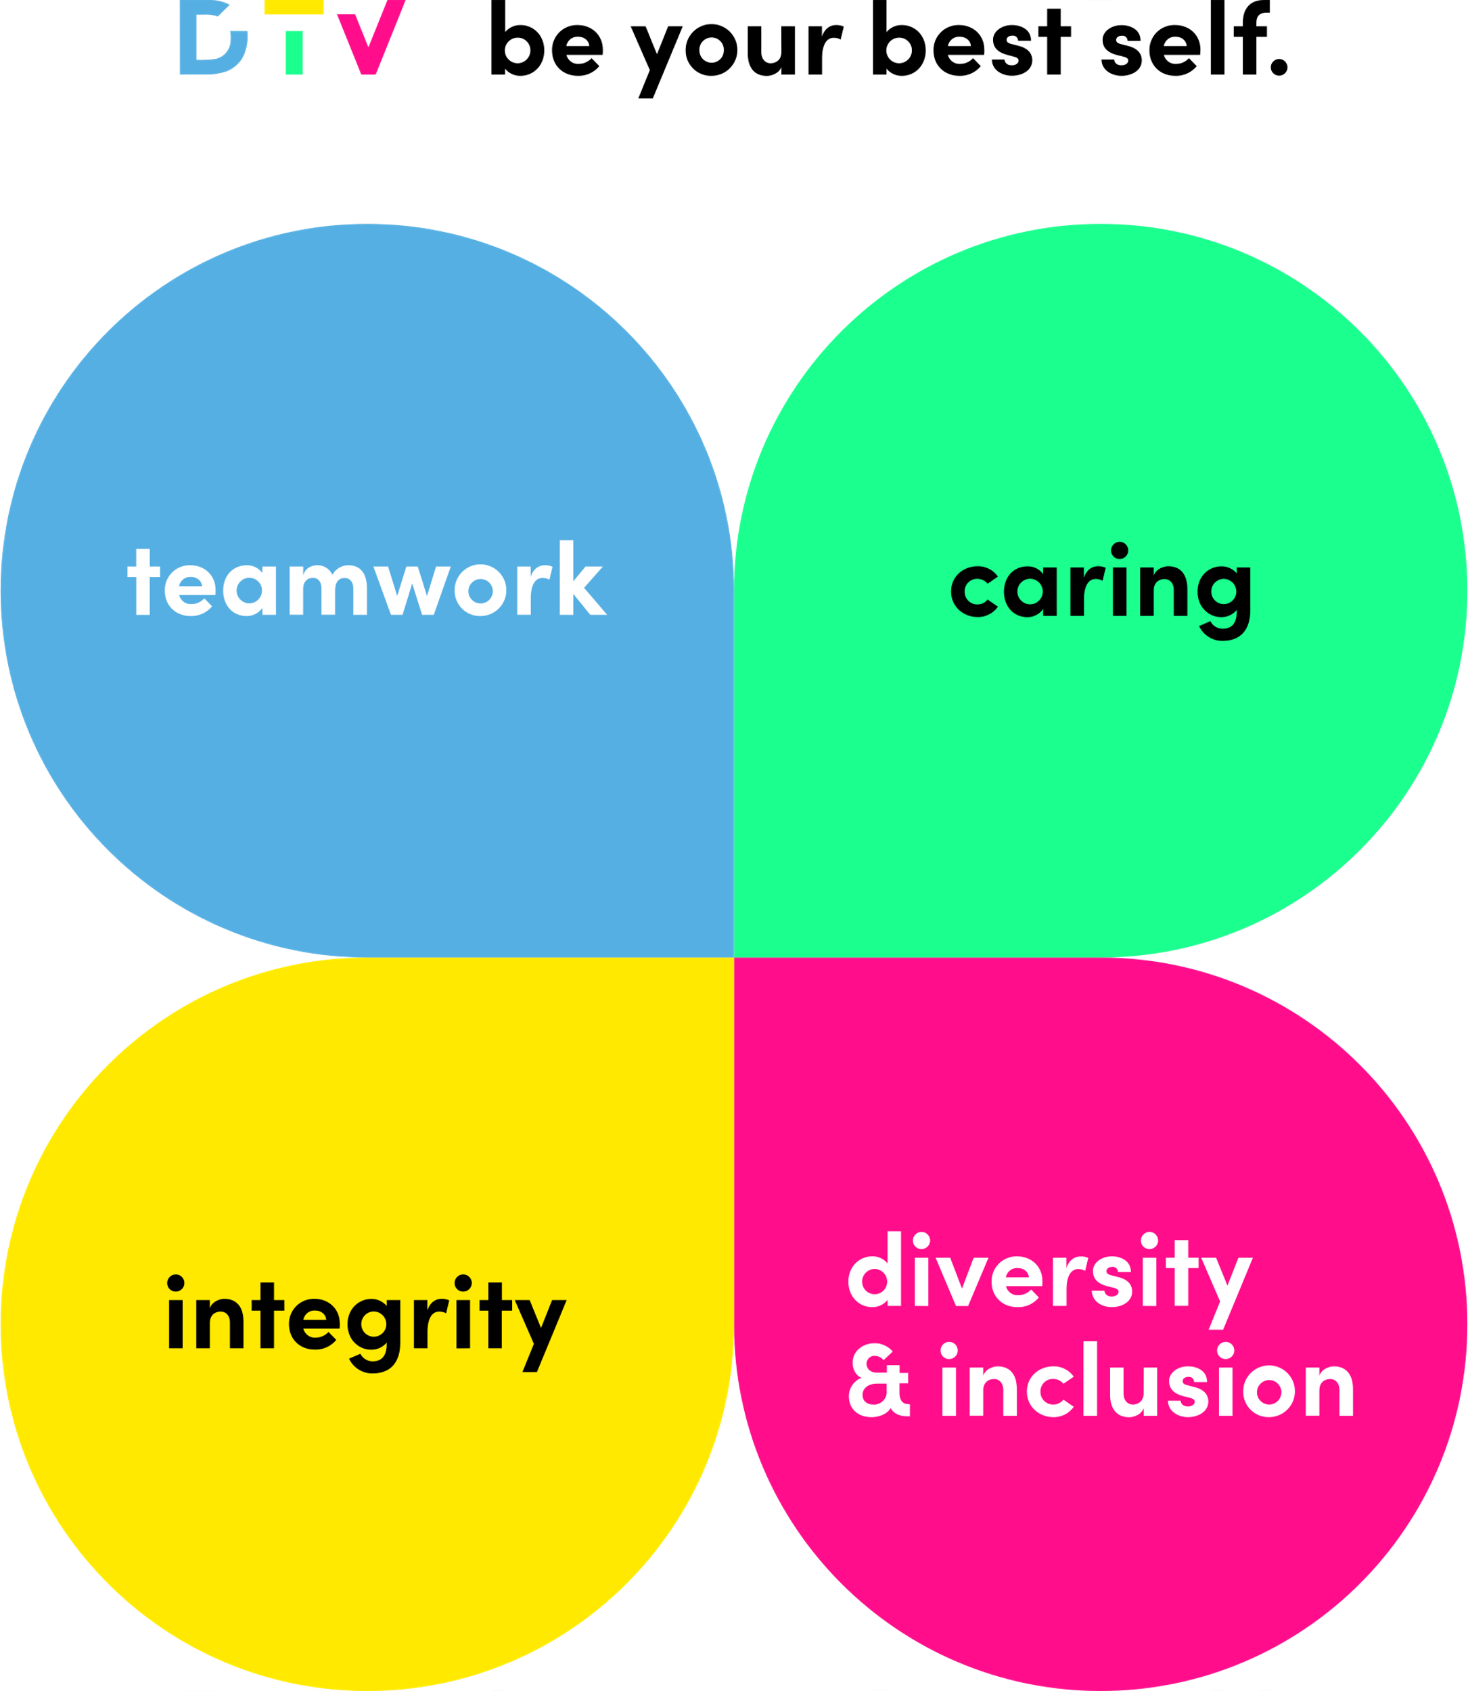 | Be your best self.  When we bring these values to life every day and in everything we do, we’ll be able to show up not only as ourselves at work, but our BEST selves.

